Manual Arizona printer DCT lab
Contents
Start-up and end of experiment 1
Performing experiments 2
Overview option menu 3
Building options 3
Homing Options 3
Reference Options 3
Feedforward options 4
Penholder options 4
Overview Speedgoat commands 5

Start-up and end of experiment
At the beginning of each session, turn on the red (1) and blue (2) power button to the target system, as shown in Figure 1. When done experimenting make sure to turn of the power again.

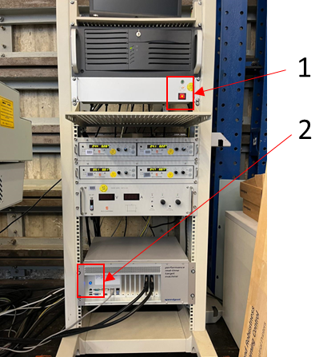
Figure 1 - Power switch target system

Performing experiments
When operating the Arizona printer, the following procedure needs to be followed:
- Open the MATLAB script “RUN_Arizona_base_GOAT.m” under the directory: C:\Users\Arizona_PC\Desktop\Arizona\ILC\Runfiles

- Set the desired settings in the MATLAB script under the section “Arizona options”.
An overview of the available settings is provided in this document.

- Run the MATLAB script with the setting optBuild = ‘true’.
ALWAYS MAKE SURE THE POWER SWITCH (Figure 2) IS TURNED OFF WHEN BUILDING!

- Run the MATLAB script with the setting optBuild = ‘false’. The trial data figure will be opened. When the prompt "Confirm that the reference stays within bounds!” is shown, check the loaded reference with respect to the Arizona bounds and the selected home position in the trial data figure.

- When the prompt “Confirm that the Arizona power switch is on!” is shown, please validate the the multimeter shows zero DC voltage!, and then turn switch (1) and press button (2), as shown in Figure 2.
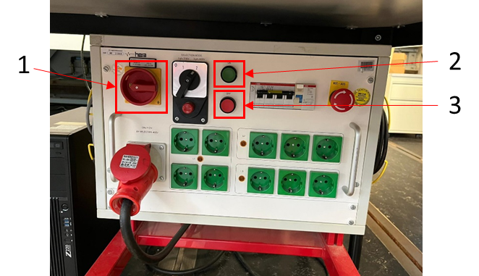
Figure 2 – Power switch Arizona
- When the prompt “Apply feedforward signal?” is shown, make sure to check the feedforward signal in the trial data figure. After confirming, the homing sequence will start. When the homing sequence is completed the trial sequence will begin immediately. Repeat this step until the desired number of trials are completed.

- After completing the specified number of trials, the prompt “Continue Experimenting?” will be shown.
  - “Yes”: A new experiment can be started without rebuilding. Rerun the MATLAB script with the updated settings. Note that changes that will affect the Simulink model e.g., changed array length of reference will require a rebuild.

  - “No”: The Simulink run will be stopped. Make sure to turn off the power to the Arizona again by pressing button (3) in Figure 2. If starting a new experiment redo the procedure.

Overview option menu
The option menu is added such that the Arizona can mainly be operated by only making changes to this part of the MATLAB code. The available options are:

Building options
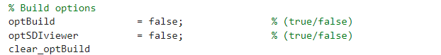
This setting controls building of the Simulink model and loading it to the target. When starting a new experiment session, the model needs to be built. Always make sure that the Arizona power switch is turned off when building the model. A rebuild is only necessary when changes affect the Simulink model.

When set to “true” the data inspector in Simulink will be opened. The Speedgoat tracks signals via the Simulink option “Log Signal” and each of these signals can be tracked in real-time via the data inspector.

Homing Options
This setting defines the zero position of the Arizona after the homing sequence has been completed. Two default positions are added e.g., corner and center. When selecting a location, always make sure the used reference remains within bounds.
When set to “false” the homing sequence will only be used for the first trial. When set to “true” homing sequence will be used for all trials.

Reference Options
Here the name of the reference is specified. The name of the reference is specified in the function file “select_reference.m”, which can be found in the same directory as the MATLAB script. New references can be added in this function file.
Specify name of the second reference. This reference will be loaded after the trial specified in the option “optTrialRefSwitch”.
Define in which directions (y, x, phi) the reference should be active. If set to zero, the reference in this direction will become an array of zeros.
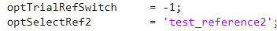
Set trial number N at which a new reference should be loaded. Reference will be used on trial N+1. Note that both references must have equal array length. If set to -1, no reference change will occur.

Feedforward options
The feedforward update is done using a function file which can be found in the directory “C:\Users\Arizona_PC\Desktop\Arizona\ILC\ILC_updates”. Details of the feedforward update are specified in the function file. Use setting to specify which function file should be used in the experiment.
Define in which directions (y, x, phi) feedforward should be active. If set to zero, feedforward in this direction will become an array of zeros.
Specify number of trials.

Penholder options
The penholder system is currently not working

Overview Speedgoat commands
This section gives a brief overview of some important speedgoat commands that are used to operate the Arizona.
tg = slrealtime('TargetPC1')
Create the target object for the default target computer. The variable defined via this command will be used to communicate to the target PC.
slbuild(model)
Build the Simulink model and convert to C code. Before building the model, the used Simulink model must be opened using the open(model) command.
tg.load(model)
Load model to the target system. When performing this step, make sure the Arizona power is switched off.
tg.start
Start running the Simulink model on the target system. Note that Simulink model must be loaded on the target using the load(model) command.
tg.stop
Stop running the Simulink model on the target system. Measurement data during run will be saved to workspace struct named ''logsOut''.
tg.stopRecording
When starting the model, the target will immediately begin streaming data. After calling this command, the data streaming will stop. The measurement data will be saved to workspace struct named ''logsOut''. Model will keep running on target system.
tg.startRecording
Start data streaming again after using the stopRecording command.
tg.getparam(model, 'Simulink parameter name')
Get parameter value of Simulink object. Can be used while the model is running on the target system.
tg.setparam(model, 'Simulink parameter name', workspace variable))
Set parameter value of Simulink object. Can be used while the model is running on the target system.

